World Trade  Organization | RESTRICTED
World Trade  Organization | WT/TPR/G/260  1 February 2012
 | (12-0621)
Trade Policy Review Body | Original: English

TRADE POLICY REVIEW

Report by

TRINIDAD AND TOBAGO

Pursuant to the Agreement Establishing the Trade Policy Review Mechanism (Annex 3 of the Marrakesh Agreement Establishing the World Trade Organization), the policy statement by Trinidad and Tobago is attached.

Note: This report is subject to restricted circulation and press embargo until the end of the first session of the meeting of the Trade Policy Review Body on Trinidad and Tobago.
CONTENTS
Page
I. Introduction 5
II. Medium term policy framework 5
III. Macroeconomic developments 6
(i) Economic growth, Unemployment and Inflation 6
(ii) Fiscal Performance 7
(iii) Balance of Payments 7
(iv) Outlook 8
IV. INSTITUTIONAL FRAMEWORK 9
(i) Ministry of Trade and Industry 9
(ii) Economic Development Board 9
(iii) Trade Facilitation and International Competitiveness 9
V. TRINIDAD AND TOBAGO’S TRADE RELATIONS WITH THE REST OF THE WORLD 10
(i) CARICOM Single Market and Economy (CSME) 10
(ii) CARICOM Bilateral Trade Agreements 10
(iii) Trinidad and Tobago Bilateral Agreements 11
(iv) ACP-EU Cotonou Partnership Agreement 11
(v) CARIFORUM-EU Economic Partnership Agreement 11
(vi) CARIBCAN 12
(vii) Caribbean Basin Initiative (CBI) 12
VI. MULTILATERAL FORUM 12
(i) World Trade Organization 12
(ii) Aid for Trade 12
VII. SECTORAL DEVELOPMENTS 13
(i) Services Sector 13
(ii) Telecommunications 13
(iii) Financial Sector 14
(iv) Energy Sector 14
(v) Agriculture Sector 14
VIII. conclusion 14

Introduction
          - During the period under review (2005-11), Trinidad and Tobago's economy experienced mixed fortunes as it was not immune to the contagion effects of the global economic crisis. However, real GDP growth averaged 3.28 percent annually. Trinidad and Tobago also continues to be a preferred destination for FDI having attracted $US6.7 billion in investment during the period
2005-10. Additionally, the country’s international credit rating is at investment grade.
          - Despite the challenges encountered as a result of the global economic crisis, Trinidad and Tobago has been able to retain solid macroeconomic fundamentals as a result of prudent fiscal management and low debt to GDP levels. The overall debt to GDP ratio is approximately 36 percent; the relationships between international reserves and balance of payments remains positive; core inflation levels have begun to decline; unemployment has remained relatively low averaging 5 percent; and the projected GDP growth rate for 2012 is 1.5 percent.

Medium term policy framework
          - Measures to strengthen and return the economy to a path of sustainable growth are articulated in a new national development plan, the Medium Term Policy Framework 2011-14 (MTPF). The MTPF recognises that additional reforms are needed to create a more productive, competitive, diversified and innovation-driven economy that will contribute to the attainment of "Prosperity for All".
          - The MTPF identifies seven (7) interconnected development Pillars to achieve the desired economic and social transformation of the country. Integral to the MTPF is the recognition that international trade is fundamental to the country's continued prosperity. Trinidad and Tobago therefore maintains an open economy with the intention of further integrating into the multilateral trading system.
          - The main thrusts of the MTPF are as follows:
- to diversify and deepen the production base in order to ensure that in a context of depleting energy resources, the economy will continue to grow and sustain a high standard of living;
- to move the economy up the value chain, improve competitiveness and expand investment both local and foreign;
- to have a secure and safe nation and to strengthen the framework, institutions and infrastructure to support human security;
- to expand the capacity of our citizens for knowledge accumulation and use, innovation, creativity and entrepreneurial activity; and
- to reduce socio-economic and regional inequalities within our borders, move people out of poverty and promote social inclusion through more meaningful economic participation.

Macroeconomic developments

Economic growth, Unemployment and Inflation
          - During the period under review, GDP per capita grew substantially from US$12,150 in 2005 to US$15,359 in 2010. The growth in per capita income was underpinned by a period of robust real GDP growth from 2005-08, which was negatively affected by the effects of the global economic crisis thereafter. Prior to the global economic crisis, Trinidad and Tobago's annual growth was significantly above the global growth rate (See Fig 1). Trinidad and Tobago's characteristic openness to international trade (Trade/GDP ratio stood at 101 percent and 85 percent in 2008 and 2010 respectively) remains strong.
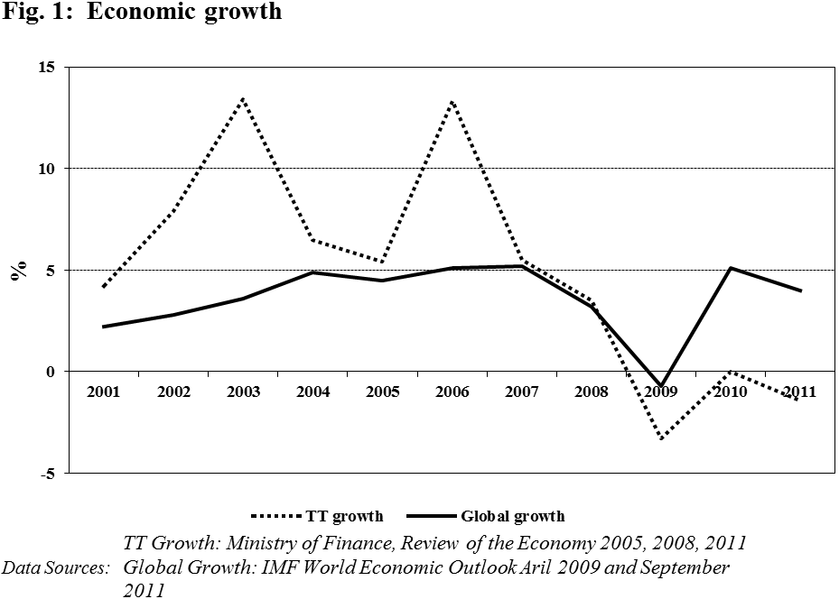

          - As a result of the fast economic growth, the unemployment rate fell from 8.0 percent in 2005 to a twenty-year record low of 4.6 percent in 2008. However, due to the effects of economic slowdown precipitated by the global economic crisis, the unemployment rate rose to 5.3 percent in 2009 and 5.9 percent in 2010 (See Fig 2). Nevertheless, the unemployment rate in Trinidad and Tobago at the end of 2011 dropped to 5.3 percent in a sign that the economic recovery is well in train.
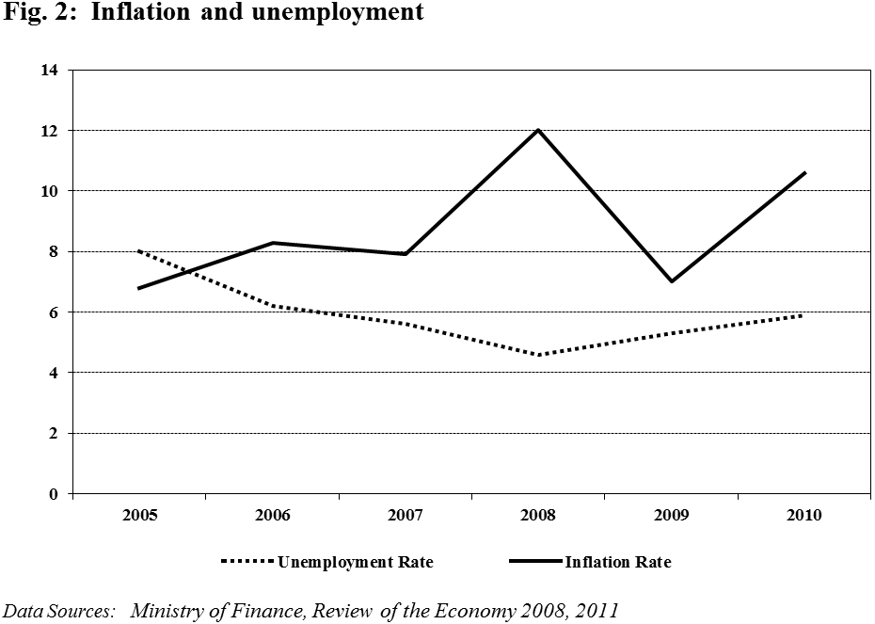

Fiscal Performance
          - Trinidad and Tobago's overall fiscal performance was mixed over the review period. In fiscal 2009, Government posted an overall fiscal deficit for the first time in over a decade as a result of the global recession and the fall in commodity prices. Crucially however, gross public debt as a percentage of GDP is projected to improve from 38.5 percent in fiscal 2010 to 36.3 percent in fiscal 2011. Thus, in terms of debt management, these figures represent a marked improvement on the 2004 levels when overall debt as a proportion of GDP stood at 51 percent. External debt service was TT$2.3 billion in 2010, which accounted for 3.3 percent of exports and represented a marked improvement on the debt service ratio of 5 percent in 2004.

Balance of Payments
          - During the review period, total merchandise exports increased phenomenally from TT$62.6 billion (circa US$9.9 billion) in 2005 to TT$116 billion (circa US$18.5 billion) in 2008. The visible trade balance during the corresponding years was valued at TT$26.7 billion (circa US$4.3 billion) and TT$56.8 billion (US$9 billion) respectively. However, due to the contagion effects of the global economic crisis, exports fell by approximately 50 percent to TT$57.7 billion (circa US$9 billion) in 2009, consequently reducing the visible trade balance to TT$13.7 billion (circa US$2.2 billion).
          - Notwithstanding the volatile international environment, exports rebounded to TT$71.1 billion (circa US$11.3 billion) in 2010, resulting in a corresponding increment in the visible trade balance to TT$29.8 billion (circa US$4.7 billion). This growth was ascribed to favourable demand from CARICOM countries and higher prices of local energy products in tandem with substantial reductions in imports of capital goods. These developments contributed to a strong current account surplus totalling US$3.8 billion at the end of calendar year 2010.
          - Therefore, notwithstanding the volatile international environment experienced over the past three years, Trinidad and Tobago's balance of payment position has remained robust. Moreover, strong export performance in 2010 resulted in a rebounding of the overall balance of payments position, occasioning a surplus of US$418.4 million from a deficit of US$712.6 in 2009 (Fig. 3). In addition, in 2010, Government made two deposits totalling US$477.3 million in the country’s Heritage and Stabilisation Fund (HSF). This pushed the total deposits to the HSF to US$2.89 billion in fiscal 2011. During the same period, gross official reserves reached US$9.0 billion, which represents 13.1 months import cover.
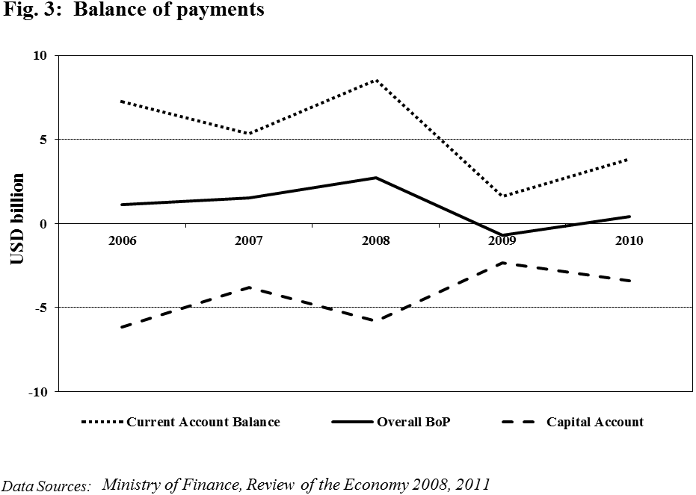

Outlook
          - Trinidad and Tobago's future economic outlook should be viewed in the context of the global environment, which has emerged from a severe economic crisis and is facing a sluggish recovery. New shocks in the European region and weak performance of the US economy, which are Trinidad and Tobago's principle markets outside of CARICOM, present a challenging outlook. However, despite uncertainty in the global environment, Trinidad and Tobago's economy remains on a sound footing to reverse the negative growth rates experienced over the past three years (2009-11). Government is consolidating measures to ensure that fiscal deficit and external debt burdens of the country remain well below international benchmarks. A strong balance of payments position currently being experienced, coupled with a healthy stock of gross official reserves and sovereign funds, constitute some of the ingredients for fiscal stability on which strong growth will be anchored. Government has also intensified efforts to transform the economy from its current strong dependence on the oil and gas sector to a diversified, knowledge intensive one and has projected a growth rate of 1.5 percent in 2012 for the economy.

INSTITUTIONAL FRAMEWORK

Ministry of Trade and Industry
          - The Ministry of Trade and Industry (MTI) has the responsibility among other things, for formulating Trade Policy and negotiating and implementing trade agreements. These functions are executed with the active participation of the private sect and the wider civil society. This institutional structure allows for the participation of elements of civil society in the policy making as well as the negotiations of trade agreements. This is done via the Cabinet appointed Technical Coordinating Committee (TCC) which is supported by Sub-Committees on agriculture, non-agriculture market access, services, investment, government procurement and Dispute Settlement and Institutional issues. The Sub-Committees provide advice to the TCC on the specific subject areas. A Standing Advisory Committee on Trade and Trade-Related Matters chaired by the TTMA also provides advice to the Minister of Trade and Industry. It's membership includes major private sector entities and other areas of civil society actors such as academia and the labour movement. The Trinidad and Tobago Coalition of Services Industries (TTCSI) an umbrella body of services associates was also established under the leadership of the Ministry of Trade and Industry to achieve closer co-ordination in the development of the services sector and the integration of their interests on services trade matters.
          - Recently, there has been an added emphasis on implementation of trade agreements. In this regard, the Ministry of Trade and Industry has established the Trade Implementation Unit (TIU) which became operational in October 2011. The main objective of the TIU is to ensure that the opportunities and benefits available under negotiated trade agreements are fully exploited by existing manufacturing, service exporters, entrepreneurs and the general public. The TIU also ensures that Trinidad and Tobago fulfils its obligations under the various trade agreements, including the CARIFORUM-EC Economic Partnership Agreement.

Economic Development Board
          - The Economic Development Board is one of the institutions identified by the Government of the Republic of Trinidad and Tobago (GoRTT) to execute the activities outlined in the "Enabling Competitive Business Strategy" which is intended to contribute to the diversification of the economy away from oil and gas focusing on the priorities of the non-energy sector. The Board is comprised of a multi-disciplinary group of stakeholders from the private sector, academia and the government.

Trade Facilitation and International Competitiveness
          - The GoRTT has placed a special emphasis on increasing the country's international ranking in competitiveness and productivity. In this regard, in January 2011, the Government established the Council for Innovation and Competitiveness to aid in improving the global competitiveness and innovation of Trinidad and Tobago over the next ten (10) years. The Council, which is comprised of various stakeholders from the private sector, is charged with (i) the mandate of developing the criteria to evaluate the competitiveness of existing businesses; (ii) monitoring, measuring and evaluating project and programme performance and outcomes within existing businesses; (iii) coordinating policy prescriptions to optimize the benefits to investment; and (iv) implementing diagnostic studies of the existing business environment and proposing changes for improvement. Over the next two years (2012-13) the Council has been given the task of ensuring the expansion of exports; improving the country's competitiveness ranking; encouraging new investments by existing competitive companies to sustain their competitiveness or develop new ventures; and increasing awareness with regard to competitiveness.
          - The Government of Trinidad and Tobago is also utilising the best practise use of Information and Communications Technology (ICT) to build a modern trade facilitation infrastructure in the country. Specifically, through the Ministry of Trade and Industry, it is implementing the Single Electronic Window (SEW) for Trade and Business Facilitation which is tailored after Singapore's TradeNet System. The system will allow companies and individuals who wish to apply for import/export permits and licences, certificates of origin, work permits, register a business/incorporate a company or conduct any other trade/business related activity to submit e-applications through one single electronic interface. When fully implemented in 2012, this initiative will revolutionise the way business is conducted in Trinidad and Tobago and will lead to substantial improvements in the country's "doing business' and global competitiveness rankings. Government, through the Customs and Excise Division, is also in the process of rolling out the ASYCUDA World customs management System, which will come into effect in 2012. This System will be integrated with the Single Electronic Window.

Trinidad and Tobago'S TRADE RELATIONS WITH THE REST OF THE WORLD
          - Trinidad and Tobago considers trade to be a significant driver of economic diversification and therefore during the review period continued an outward looking approach to trade policy and built upon a number of trade agreements involving both developed and developing countries. The involvement in these Agreements has been in coordination with other members of the Caribbean Community (CARICOM) and CARIFORUM (CARICOM countries and the Dominican Republic). In this regard, Trinidad and Tobago continues to actively participate in the growth and development of the trading bloc of CARICOM defined by the broad spectrum of disciplines related to the trade in goods and services. In general, Trinidad & Tobago's participation in trading relations at the various trade fora has been circumscribed by its membership in the CARICOM grouping in terms of harmonization of positions. Specifically, Trinidad and Tobago's direct interests have been centred on securing expanded market access for domestic exporters of goods and services, simplifying the rules which govern such access to make it meaningful, increasing inflows of foreign direct investment, and overcoming supply side constraints.

CARICOM Single Market and Economy (CSME)
          - As a member of the Caribbean Community, Trinidad and Tobago is committed to the realization of the CARICOM Single Market and Economy (CSME). The goal of this arrangement involves the removal of constraints and restrictions to permit the free movement of labour, goods, services and capital and the right of establishment throughout the Community. The Single Market became operational in January 2006. There is need however to complete the establishment of all institutional and legal arrangements. With respect to the implementation of the Single Economy, Heads of Government have decided to first consolidate the gains of the Single Market before proceeding to certain elements of the Single Economy such as the creation of a single currency.

CARICOM Bilateral Trade Agreements
          - As a member of CARICOM, Trinidad and Tobago has entered into trade agreements with Latin American countries such as the Dominican Republic, Costa Rica, Venezuela, Colombia and Cuba. The agreements with the Dominican Republic and Costa Rica are Free Trade Agreements with built-in agendas towards the completion of outstanding disciplines. The CARICOM/Venezuela Trade and Investment Agreement is currently a one-way preferential agreement, and the remaining reciprocal agreements (with Colombia and Cuba) are limited in scope. Bilateral trade agreements are considered by Trinidad and Tobago to be an effective avenue through which domestic firms can develop in preparation for participation in the wider multilateral system.

Trinidad and Tobago Bilateral Agreements
          - Trinidad and Tobago has also recently negotiated a Partial Scope Agreement with Panama and is preparing to engage other Latin American countries such as Guatemala, El Salvador and Honduras. These agreements are seen as stepping stones to the wider integration of the Caribbean and Central American economies and the facilitation of the participation of these Members into the global economy in the longer term.

ACP-EU Cotonou Partnership Agreement
          - In terms of the relationship with the European Union, the 2000 Cotonou Partnership Agreement between the African, Caribbean and Pacific Group of States (ACP) and the European Union (EU) was reviewed and amended in 2005 and 2010. The Agreement, which covers the period leading up to 2020, now focuses on development support.

CARIFORUM-EU Economic Partnership Agreement
          - In keeping with the provisions of Article 37 of the 2000 Cotonou Partnership Agreement, Trinidad and Tobago, as a member of the CARIFORUM Region of the ACP Group, participated in the negotiation of new formal trading arrangements with the European Union. These negotiations were completed and a CARIFORUM EU Economic Partnership Agreement (EPA) was signed with the European Union by Trinidad and Tobago and other CARIFORUM Countries, on 15 October 2008. The trade provisions of the Cotonou Partnership Agreement have therefore been replaced by the EPA. The agreement is a permanent arrangement which provides exporters of nearly all CARIFORUM products with duty free and quota free access to the EU market for originating goods. The Agreement is being provisionally applied by Trinidad and Tobago since 2008. It has been notified to the WTO under GATT Article XXIV.
          - The objectives of the EPA are:
- Contributing to the reduction and eventual eradication of poverty;
- Promoting regional integration and economic cooperation;
- Promoting the gradual integration of CARIFORUM States into the world economy;
- Improving the capacity of CARIFORUM States in trade policy and trade related issues;
- Supporting conditions for increasing investment and private sector initiative and enhancing supply capacity; and
- Competitiveness and economic growth of CARIFORUM States.

CARIBCAN
          - Trinidad and Tobago continues to be a beneficiary of the 1986 Caribbean/Canada Trade Agreement (CARIBCAN) which provides non-reciprocal duty free access to the Canadian market for a range of goods from participating CARICOM countries. The WTO General Council, at the request of Canada, has recently extended the MFN waiver for CARIBCAN to 2013. Trinidad and Tobago and other CARICOM partners are now involved in the negotiation of a reciprocal trade and development agreement with Canada. It is projected that this Agreement, consistent with Article XXIV of the GATT, will be concluded before the expiration of the WTO waiver.

Caribbean Basin Initiative (CBI)
          - The Caribbean Basin Initiative (CBI) comprises the Caribbean Basin Economic Recovery Act (CBERA) and the Caribbean Basin Trade Partnership Act (CBTPA). Trinidad and Tobago has been a major beneficiary of this regime during the review period. In fact, Trinidad and Tobago became the leading exporter to the United States under the CBI since 2006. In 2010 Trinidad and Tobago exported US$2.2 billion to the US under CBI tariff preferences. The CBTPA was recently extended until 30 September 2020, through the HELP Act (May 2010). In addition, the WTO General Council approved a further MFN waiver for the CBERA up to 2014.

MULTILATERAL FORUM

World Trade Organization
          - Trinidad and Tobago remains firmly committed to a fair and equitable rules-based multilateral trading system that is supportive of the development pursuits of Members and which it considers to be the foundation of its relationship with trading partners. As a small and vulnerable economy (SVE) with supply-side capacity constraints, Trinidad and Tobago recognises the importance of trade as a development tool and therefore looks to the multilateral trading system as an avenue to reduce its vulnerabilities.
          - Trinidad and Tobago is deeply committed to the negotiating process under the Doha Development Round since it recognizes that its successful conclusion will bring benefits to all members. However, we advocate a pragmatic approach involving a Work programme that takes due cognizance of the unique issues related to SVEs.
          - Trinidad and Tobago has consistently implemented the WTO Agreements and continues to fulfil its transparency obligations via the WTO notifications and trade policy review processes.

Aid for Trade
          - Trinidad and Tobago supports the mobilization of additional predictable, sustainable and effective financing as being central to the Aid for Trade (AfT) Initiative. For Trinidad and Tobago, AfT resources are seen as a short to medium term input into building supply capacity to make use of negotiated market access. In this regard, the GoRTT, in collaboration with the Inter-American Development Bank (IADB), is currently developing a National Aid for Trade (AfT) Strategy which is to be finalized by the end of March 2012.
          - As part of the Caribbean Community, Trinidad and Tobago is also an active participant to the Regional AFT Strategy being developed by CARICOM. It is envisaged that there will be complementarity between the goals of the regional and national AfT Strategies. Trinidad and Tobago recognizes the importance of engaging in active participation in the Global as well as the Regional Review on Aid for Trade and makes every effort to participate in these meetings. Trinidad and Tobago also supports entrusting the WTO Secretariat with the role of monitoring and mobilizing additional Aid for Trade resources.

SECTORAL DEVELOPMENTS
          - Sectoral developments are being propelled by Government's stated efforts to achieve economic diversification in the understanding that the country's energy resources are finite. The thrust towards a knowledge-based and innovative economy represents a shift away from dependence on hydrocarbon resources to a commitment to the development of human capital.

Services Sector
          - The services sector has maintained a significant share of GDP and employment with an estimated 45.9 percent share of GDP and some 84.1 percent of employment being accounted for by the sector in 2010. Government aims to advance the process of the country's economic transformation through building a competitive economy that is technology-driven, innovative, knowledge-based and globally connected. In this context, the basis for this will be the acquisition, exploitation, creation and strategic deployment of knowledge and skills in the services sector so as to ensure the provision of services of higher value. Areas that are being targeted include Energy services, financial services, tourism services, Creative Industry services and ICT services.
          - One of the pillars of the National Planning Framework is, in fact, the creation of a diversified and knowledge intensive economy. In this regard, focus will be given to the contribution of indigenous knowledge and heightened emphasis on research and development. Key among the initiatives in this area will be the establishment of a National Innovation System.
          - In addition, a National Services Industry Strategy is to be devised and will guide the development of the various sub-sectors in a co-ordinated manner. The Policy will be the result of an in-depth consultative exercise, inclusive of a statistical survey of the sector, which will provide a roadmap for the development of the Services Sector. A key element of the Policy will be the expansion of market access for services and it will also address critical national development needs of the sector.
          - The specific objectives of the Policy include: the determination of services-related goals, targets and priorities of the economy; offering some measure of predictability to investors of the national services environment; defining the role of the public and private sectors in services activities, and identifying a mechanism for the meaningful participation of private enterprise; providing policy direction in the external negotiation of trade in services; and providing a basis for legislative and institutional interventions.

Telecommunications
          - The liberalization of the sector has proceeded and continues to be governed by the following objectives: competition to ensure a healthy, fair and competitive environment is sustained; and the development of frameworks, plans, programmes and projects to ensure the achievement of the social and economic objectives of liberalization such as universal service, affordable and competitive prices and the availability of multiple service providers in the various markets. Government is implementing the Broadband Strategy for Trinidad and Tobago to facilitate the provision of reliable, affordable, high-speed Internet services to all citizens. In addition, in 2011 Government passed two key pieces of legislation to advance the use of ICTs in Trinidad and Tobago. These are the Data Protection Act (2011), which seeks to protect the privacy of personal and private information of individuals which is entered in electronic format; and the Electronic Transactions Act (2011), which gives legal effect to electronic documents, records and signatures.

Financial Sector
          - Government is currently in the process of building renewed confidence in the financial sector through proposed measures of a regulatory nature. These include expanded deposit insurance coverage as well as additional powers for the Central Bank of Trinidad and Tobago through amendments to the Central Bank Act.

Energy Sector
          - Traditionally, Trinidad and Tobago's operations in the energy sector have taken the form of oil and gas exploration and production, exploitation of asphalt deposits and the production of methanol. While oil and gas exploration and production continues to be the main stay of the sector, the Government of the Republic of Trinidad and Tobago has taken an interest in pursuing new investments in the down- stream energy sector as well as in alternative and renewable energy.
          - During the period under review, there was a thrust by the Government to develop the down-stream gas-based industries, expanding into the production of urea, methanol and ammonia. The Government has also embarked on the development of a Sustainable Energy Policy which is aimed at maximising the efficient production and use of fossil fuels.

Agriculture Sector
          - Government's policy focus in this sector is geared toward the development of a modern productive agricultural sector that is internationally competitive and that generates sustainable income levels for producers and ensures food security for the nation. Some of the strategic initiatives which will be implemented in the medium term and aimed at revitalizing the sector include: increased agricultural production, distribution and access; development of a water resources management strategy; improvement in land management and tenure of farmers; expansion of source markets for imports; encouragement of youth participation in the agricultural sector; higher levels of productivity for locally produced goods and the consumption of healthy, locally produced food; and the creation of linkages between the agriculture and other productive sectors.

conclusion
          - Since its last Review, Trinidad and Tobago has continued its active involvement in the multilateral trading system. Our commitment to free and fair trade is evidenced by the fact that despite the global financial crisis the Government of Trinidad and Tobago maintained an open and liberalized trade policy and did not resort to any protectionist trade measures. We have also continued to fulfil our obligations under the various WTO Agreements.
          - In the future, our trade policy will continue to be aimed at deepening the integration of the economy into the global economy so as to achieve the economic and social transformation of the country.

__________

9th Report to Congress on the Operation of the Caribbean Basin Economic Recovery Act, prepared by the Office of the US Trade Representative, December 31, 2011.

